Using the NegoSim to Simulate the Automated Negotiations
Arash Ebrahimnezhad¹ and Katsuhide Fujita²
¹ Faculty of electrical and computer engineering, Babol Noshirvani University of Technology, Babol, Iran
Arash.ebrah@gmail.com
² Institute of Engineering, Tokyo University of Agriculture and Technology, Tokyo, Japan
katfuji@cc.tuat.ac.jp
Abstract. NegoSim is an automated negotiation simulator. This document helps users to install and run NegoSim, develop their automated negotiation agents, protocols, analysis entities, and customize the GUIs of NegoSim.

- Architecture of NegoSim
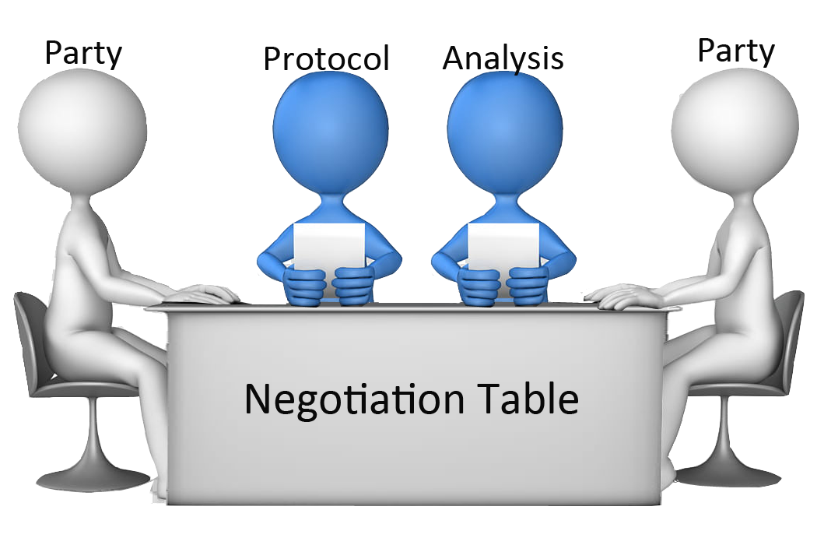
Fig. 1. The most important entities of NegoSim are the negotiation table (NegoTable), parties, analysis entity, and protocol entity. The protocol is the most critical entity which controls all negotiation events.
In Fig. 1 the important entities of NegoSim are demonstrated. In table 1 the entities of NegoSim and their description are detailed. The important classes and their relationships are shown in Fig. 2. As it is shown in Fig. 2 the parties do not have direct access to the protocol but each time the protocol calls the parties to send their bid, the parties are provided access to the protocol. The send_bid abstract method in AbstractNegoParty class gets the protocol as its argument, see Fig. 3.
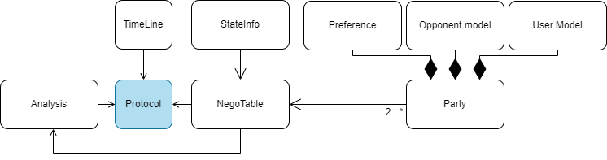
Fig. 2. Partial UML of core of NegoSim. The important classes of NegoSim are depicted.
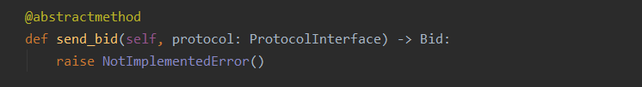
Fig. 3. send_bid is an abstract method that should be implemented by the agent developer. This method has an arguments protocol. This method is called by the protocol and it passes this parameter to the send_bid method, so the party has access to the protocol in this method.
Table 1. The most important entities of NegoSim are described.
Entity | Description
Negotiation table (NegoTable) | It has access to the negotiation parties and status information (StateInfo) which refers to the negotiation state (0: negotiation is ongoing, 1: negotiation is ended with reaching an agreement, -1: negotiation is ended without reaching an agreement). Exchanged offers would be added to the negotiation table; in other words, the negotiation table contains the exchanged offers.
Parties | The participants in the negotiation are known as parties.
Analysis | It has access to NegoTable and consequently parties' preferences, parties' opponent models, and user models (if those exist) to analyze the negotiation result and agents' performance.
Protocol | The most important entity which controls the negotiation is protocol. A protocol has access to three entities:  - It accesses the negotiation table and consequently the parties and their exchanged offers.  - It accesses to the Analysis entity which can be used to analyze the negotiation and parties' performance.  - It accesses the TimeLine entity which is used by the protocol to control the negotiation time.  Parties can access the protocol to ask any question about the negotiation and the protocol answers them according to the negotiation laws.
- Domain, Preference
If it is assumed the negotiation would be on the buying/selling laptop (Laptop domain) and if it is assumed a laptop has three negotiable issues (Brand, Hard disk capacity, and Monitor size), each of these issues could have several items, see table 2.
Table 2. Laptop domain with 3 negotiable issues
Domain name | Issues and weights | Values and evaluations
Laptop | Brand weight = (0.6) | Dell evaluation = 1
Laptop | Brand weight = (0.6) | Lenovo evaluation = 2
Laptop | Brand weight = (0.6) | Mac evaluation = 3
Laptop | Hard disk capacity weight = (0.25) | 1 T evaluation = 1
Laptop | Hard disk capacity weight = (0.25) | 2 T evaluation = 4
Laptop | Hard disk capacity weight = (0.25) | 3 T evaluation = 5
Laptop | Monitor size weight = (0.15) | 19 inch evaluation = 7
Laptop | Monitor size weight = (0.15) | 17 inch evaluation = 5
Laptop | Monitor size weight = (0.15) | 15 inch evaluation = 1

Each issue has a weight that represents its priority e.g. $w\left(Brand\right)=0.6$ and for each item, a value is assigned e.g. $eval\left(Dell\right)=1$.

- Utility Space
NegoSim does not restrict the users (researchers/developers) to using predefined utility spaces. They can develop their own utility spaces. In NegoSim linear additive utility space is defined (see NegoSim/utility_spaces/AdditiveUtilitySpace.py). To create a special utility space the developer should extend AbstractUtilitySpace (NegoSim/core/AbstractUtilitySpace). The abstract methods of AbstractUtilitySpace class are shown in Table 3.

Table 3: abstract methods of AbstractUtilitySpace class that should be implemented.
Method | Description
get_utility | This method receives a bid and returns a utility of it.
get_utility_distinct | This method receives a bid and returns a utility of it according to the negotiation time passed from the beginning of the negotiation: $u^{'}(ω)=u(ω)*d^{t}$ in which $u^{'}$ is the utility of $ω$ with time pressure, u is the utility of bid $ω$ without time pressure and d is discounted factor which is defined in preference and $t$ is the time passed from the beginning of the negotiation (see section 4.1).

The AbstractUtilitySpace class which you can find in path NegoSim/utility_spaces/ AbstractUtilitySpace.py uses additive utility space. This kind of utility space uses a linear additive formula to calculate the utility of a bid, see Eq. 1. In this way of calculating the utility of a bid will be in the range of 0 and 1 (Eq. 2).
$u\left(ω\right)=u\left(v^{1}, …, v^{n}\right)=\sum_{i}^{n}{w(i)}*\frac{eval(v^{i})}{\max{(eval(I_{i}))}}$ (1)
$u\left(ω\right)∈[0,1]$ (2)
In Eq. 1, $ω$ and $u\left(ω\right)$ refer to the possible outcome of a domain and utility of the $ω$ respectively and $\left(v^{1}, …, v^{n}\right)$ refers to the values of the issues, if it is assumed the $ω=\left(v^{1}, v^{2}, v^{3}\right)=(Dell, 1T, 19 inch)$ then $u\left(ω\right)$ equals to:

$u\left(ω\right)=u\left(Dell, 1T, 19 inch\right) =\sum_{i=1}^{3}{w\left(i\right)}*\frac{eval\left(v^{i}\right)}{\max\left(eval\left(I_{i}\right)\right)}$

$= w\left(Brand\right)*\frac{eval\left(Dell\right)}{max⁡(eval\left(Dell\right), eval\left(Lenovo\right), eval(Mac)}+ w\left(Hard Disk\right)*\frac{eval\left(1T\right)}{max⁡(eval\left(1T\right), eval\left(2T\right), eval(3T)}+ w\left(Monitor Size\right)*\frac{eval\left(19inch\right)}{max⁡(eval\left(19inch\right), eval\left(17inch\right), eval(15inch)}$

$=0.6*\frac{1}{3}+0.25*\frac{1}{5}+0.15*\frac{7}{7}=0.4$
- Preference creation
NegoSim provides two ways to create a preference: using XML files and Python dictionary data structure.
  - Using xml files
To create a domain, it is enough to create a folder with the domain name in path NegoSim/Domains, e.g. laptop. In the laptop directory, at least two preference files in XML format should be created, e.g. laptop_buyer_utility.xml and laptop_seller_utility.xml. Each of these XML files should contain scripts like Fig. 4.

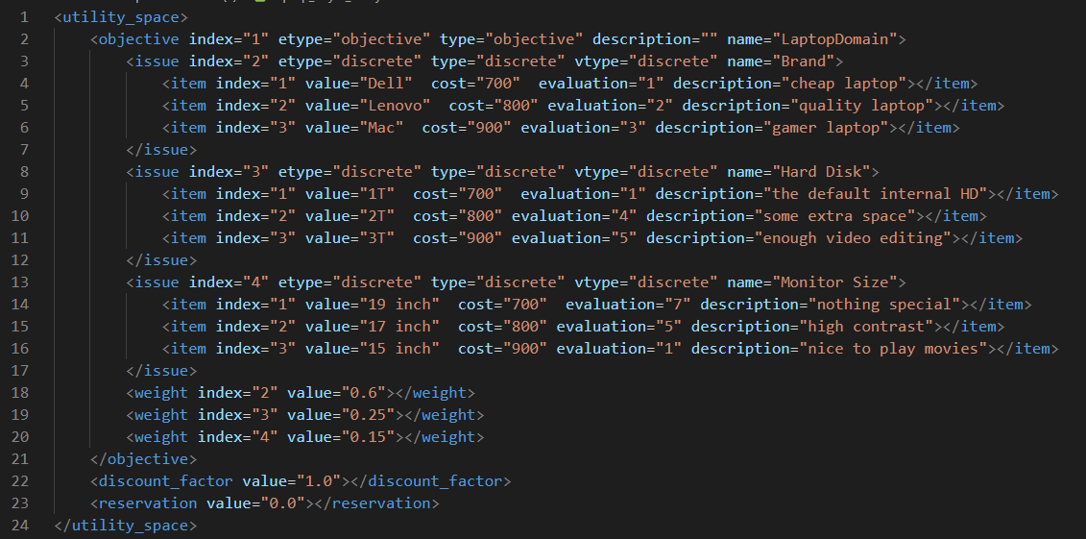
Fig. 4. A preference for the laptop domain is defined in an XML file.

As it is shown in Fig. 4, all tags must be inside utility_space tags (<utility_space> … </utility_space >). An issue is defined by the issue tag and inside the issue tags the available items and their evaluations are defined (lines 3 to 7, 8 to 12, and 13 to 17 define three items and their evaluations). The weights of issues are defined in lines 18, 19, and 20.
Some negotiation scenarios could have time pressure, in this situation the utility is calculated by Eq. 3.
$u^{'}\left(ω\right)=u\left(ω\right)*d^{t}$ (3)
In Eq. 3, $u\left(ω\right)$ refers to the utility of bid $ω$, and the utility of that bid with time pressure is shown by $u^{'}\left(ω\right)$. $d$ and t ($t∈[0, 1]$) refer to discounted factor and time respectively. the discounted factor is defined in line 22 in Fig. 4. If discount factor is equal to 1, it means there is not time pressure.
Some negotiation scenarios could have reservation value which means if the negotiation would be ended without an agreement the agent could have the utility equal to the reservation value. In other words, the rational negotiation agent would not accept a bid with a utility that is less than the reservation value. In Fig. 4 the reservation value is defined in line 23.

Please Note: A preference should have reservation value and discounted factor tags, in other words, lines 22 and 23 in Fig. 4 are crucial. If there is no time pressure and reservation value you can evaluate them as 1 and 0 respectively.

  - Using Python dictionary data structure
NegoSim provides developers to create a preference by creating a python dictionary like Fig. 5In this way of preference creation the issues are defined as dictionary keys and their values should be a list with 2 items, first item determines the weight of the issue and the second one should be a dictionary in which the key and values of it refer to the item and evaluation of the item, see lines 2 to 4 in Fig.5. In lines 5 and 6 in Fig. 5 discount factor and reservation value are defined.
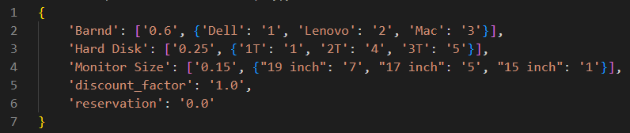
Fig. 5. Lines 2 to 4 define issues and their weights and items. Lines 5 and 6 define discounted factor and reservation value respectively.
To create a preference, after creating a Python data structure like Fig. 5, you can simply send this data structure as a parameter to the init method of the Preference class.

Please Note: A preference should have reservation value and discounted factor, in other words, lines 5 and 6 in Fig. 5 are crucial. If there is no time pressure and reservation value you can evaluate them as 1 and 0 respectively.

- Protocol
A protocol is the most important entity at the NegoSim. It determines how the agents communicate with each other. NegoSim provides some APIs through which the users can develop their protocol, however, there is a predefined protocol called SOAP [1]. In the following, you can find the implementation of SOAP and how to create a protocol.

  - Create a protocol
To create a protocol, a user at least must implement the core.ProtocolInterface. We recommend extending the core.AbstractProtocol which is a basic implementation of the core.ProtocolInterface. The abstract methods that should be implemented by a protocol developer are demonstrated in table 4:

Table 4. Abstract methods of abstract class AbstractProtocol and their descriptions.
Method | Description
negotiate | This method asks for a bid from parties according to sequence and negotiation status, after receiving a bid then convert it to an offer (by adding time to the bid) and add it to the offers on the table, and updates the status of the negotiation.  - Negotiation status will be 1 if the last parties' offers are the same which means the negotiation was ended by reaching an agreement.  - Negotiation status will be 0 if the last parties' offers are not the same or an instance of the EndNegotiation (core/AbstractNegoParty) class which means the negotiation is continuing.  - Negotiation status will be -1 if at least the one of last received bids is an instance of EndNegotiation class or negotiation was ended without an agreement.
get_offers_on_table | This method gets a party name in string type and returns a tuple of offers related to the party name that has got through the object that has called the method.  Before returning the offers, the method checks out whether the object that has called the method has the authority to access the offers or not? If there is no permission it returns an error.  Predefined SOAP protocol lets all parties know each other's offers.

NegoSim has provided SOAP protocol (see negosim/protocols/SOAP.py). A protocol accesses to the TimeLine, NegoTable and AnalysisMan objects through its parent class and accesses to negotiation Parties and StateInfo objects through the NegoTable. A protocol is obliged 3 tasks:
- Investigation of negotiation status using this line of code: self.get_nego_table().get_state_info().get_negotiation_state(). Lines 1 and 6 in Fig. 6. This line of code can return 3 different values:
  - 1: the negotiation ended by reaching an agreement
  - -1: the negotiation ended without reaching an agreement
  - 0: the negotiation is ongoing.
A protocol must ask parties for bids if the negotiation is ongoing.

- If the negotiation is ongoing, before asking parties for bids, a protocol should investigate whether is there negotiation time left? To investigate the negotiation time a protocol must use this line of code: self.get_time_line().is_time_ended(), line 4 in Fig. 6. If this line of code return true then the protocol asks parties for bids using this line of code:
party.send_bid(self, self.get_time_line()), line 7 in Fig. 6, otherwise updates the status of the negotiation to -1 using this line of code: self.get_nego_table().get_state_info().set_negotiation_state(-1), lines 5 and 17 in Fig. 6.

- Every time that the protocol gets a bid, the protocol has to convert the bid to an offer using this line of code: Offer(bid, self.get_time()) then add this offer to the negotiation table using this line of code: self.get_nego_table().add_offer(party, offer), lines 8 and 9 in Fig. 6.
If you want track each party's accuracy of user modeling and opponent modeling, you should call cal_estimation_analysis_data() method, line 11 in Fig. 6. cal_estimation_analysis_data() is a method of analysis entity, see section 6.

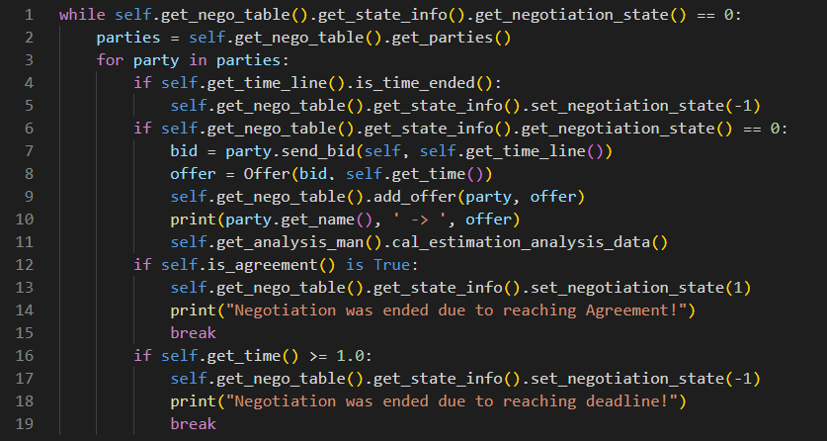
Fig. 6. Three crucial tasks that a protocol should implement.

Please Note: if you want to use your developed protocol using NegoSim GUI, you have to create a class with the same name as the module name. E.g. if you create a module SOAP.py, you should create an SOAP class.

- Create a negotiation party
To create an automated negotiation party, the AbstractNegoParty (in module core.AbstractNegoParty) class should be extended. The abstract methods of AbstractNegoParty are shown in table 5.
Table 5. Abstract methods of AbstractNegoParty class.
Method | description
send_bid | This method is called by protocol. This method decides which bid should be sent to the opponent. In this method, an agent can send the opponent's last offer if it wants to accept opponent's offer. If an agent wants to end the negotiation without a result (walk away) sends an instance of EndNegotiation class otherwise sends its counteroffer
get_name | The name of the agent should be declared here.
get_opponent_model | If you want the accuracy of the opponent model to be investigated by the AnalysisMan entity this method should return the opponent model.  If you do not want to investigate the accuracy of the opponent model you can write "return None".
get_user_model | If your agent was developed to negotiate in uncertain situations and you want the accuracy of the user model to be investigated by the AnalysisMan entity, this method must return the user model, otherwise please write "return None" in this method.
There are some negotiation parties in the path NegoSim/Agents. The RandomParty1 is a simple agent which chooses the random bid to send to the opponent. The important method of RandomParty1 is send_bid which is shown in Fig. 7:
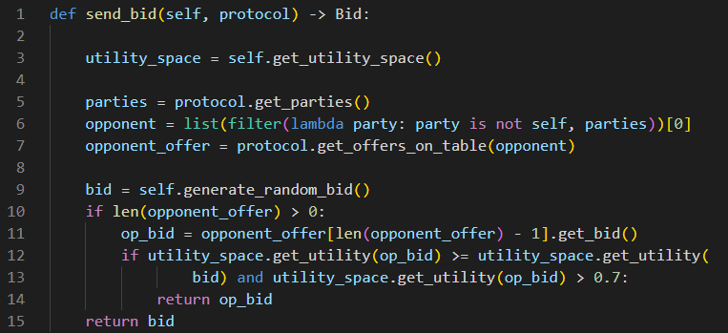
Fig. 7. This Fig. shows the send_bid method for the RandomParty1.
The agent's utility space is gained in line 3. An agent can access the protocol so if the agent has any questions about the opponent(s), exchanged bids and etc. should ask protocol, so in Fig. 1 the RandomParty1 asks protocol about all participants in the negotiation, line 5. The opponent object is gained using line 6. All negotiation exchanged offers are on the table, so if the agent wants to access these offers should ask the protocol to return the existing offers on the table. Line 7 shows RandomParty1 wants to know the received offers. The bid which may be sent to the opponent is generated randomly in line 9 (next_bid). If the opponent had sent the offer at least one offer (line 10) then the last opponent's offer is extracted (op_bid, line 11). The utility of the op_bid and next_bid regarding its utility space are calculated in lines 12 and 13 (op_bid_u, next_bid_u) respectively. Line 12, 13 investigate if the op_bid_u is greater than or equal to next_bid_u and the op_bid_u is greater than 0.7 then accept the opponent's offer (line 14); otherwise, send the counteroffer to the opponent (line 15). In NegoSim if an agent accepts the opponent's offer, then just sends the received offer to the opponent. When the agents' last offers are equal the protocol announces the negotiation has been finished by reaching an agreement. For full implementation of RandomParty1, see NegoSim/Agents/RandomParty1.py.

Please Note: An agent can access the protocol so if the agent has any questions e.g. about the opponent(s), exchanged bids and etc. should ask the protocol.

There is EndNegotiation class in the module AbstractNegoParty (core.AbstractNegoParty). This class has inherited the Bid class so if an agent wants to finish the negotiation (walk away), it can create an instance of EndNegotiation class and send it to the opponent. The protocol investigates the agents' offers and if it is an instance of EndNegotiation then finishes the negotiation.

Please Note: if you want to use your developed agent using NegoSim GUI, you have to create a class with the same name as the module name. E.g. if you create a module RandomParty1.py, you should create a RandomParty1class.

  - BOA framework
The other way to develop a negotiation agent is using the BOA [2] framework. In this way, the user must develop three components: Bidding strategy, Opponent model, and Acceptance strategy. NegoSim provides predefined BOA components. RandomStrategy as bidding strategy which selects the bid randomly (see NegoSim /bidding_strategies/RandomStrategy.py), DefaultOpponentModel as opponent modeling (see NegoSim/opponent_models/DefaultOpponentModel.py) and, ACNext [3] as acceptance strategy (see NegoSim/acceptance_strategies/ACNext.py). RandomParty2 uses the BOA framework (see NegoSim/Agents/RandomParty2.py). To use the BOA framework, the developer of the agent must extend the AbstractNegoParty and override the init method, see Fig. 8.
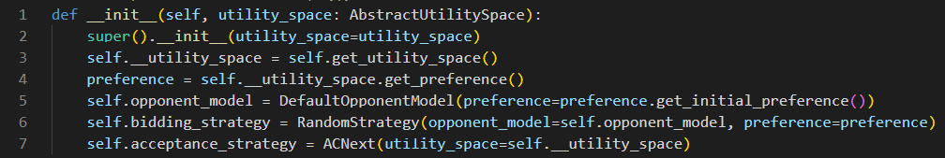
Fig. 8. This Figure illustrates how to override the init method
Line 3 in Fig. 2 gets the agent's utility space and uses it to extract the agent's preference (line 4). The agent's preference is used to define the opponent model (self.opponent_model line 5). In line 5 the bidding strategy was defined (self.bidding_strategy). Line 6 defines the agent's acceptance strategy (self.acceptance_strategy).
RandomParty2 uses this line of code: bid = self.bidding_strategy.send_bid(timeline) to find a bid to send to the opponent, to update the opponent model uses this line of code: self.opponent_model.update_preference(op_offer) and, to decide whether to accept the opponent offer or not uses this line of code: self.acceptance_strategy.is_acceptable(offer=op_offer, my_next_bid=bid, opponent_model=self.opponent_model). If this line returns True value then the agent accepts the opponent's offer otherwise sends the counteroffer.

Implement Bidding strategy. To implement the bidding strategy in the BOA framework, we recommend extending the AbstractBiddingStrategy class. You must implement the abstract method send_bid. NegoSim has provided RandomStrategy (see NegoSim/bidding_strategies/RandomStrategy.py). AbstractBiddingStrategy class provides a method to generate random bids, so the RandomStrategy is like Fig. 3:
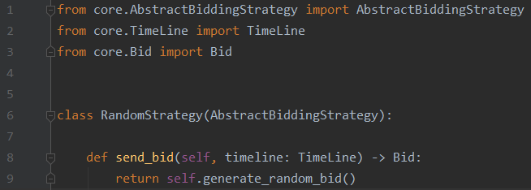
Fig. 9. RandomStrategy class has extended the AbstractBiddingStrategy and Implemented the send_bid method.

Implement Opponent model. To implement an opponent model in the BOA framework, we recommend extending the AbstractOpponentModel. This class has a method get_initial_opponent_preference() which returns an initial preference. In initial preference, the weights are calculated by Eq. 1:
$w_{i}= \frac{1}{n}$ (4)
In Eq. 1, $w_{i}$ and n refer to the weight of i'th issue and the number of issues in the domain respectively. The evaluation of a value is set to 1. AbstractOpponentModel class has an abstract method update_preference(self, offer: Offer) that should be implemented.

Implement Acceptance strategy. To implement an acceptance strategy, we recommend extending the AbstractAcceptanceStrategy. This class has an abstract method is_acceptable which should be implemented. This method can return two integer values: 0 and 1 referring to reject and accept the opponent's offer, respectively. NegoSim has provided an acceptance strategy which is called ACNext (see NegoSim/acceptance_strategies/ACNext).
  - Developing a party with preference uncertainty
In preference uncertainty the agent does not know the exact preference of the user; instead of it the user gives the agent some ranked bids:
$ω_{1}≼ ω_{2}≼…ω_{k-1}≼ ω_{k}$ (5)
In Eq. 1 $ω$ refers to a possible outcome of domain space, symbol $≼$ determines the desirability of a possible outcome relative to the others, e.g. $ω_{1}≼ ω_{2}$ demonstrates $ω_{2}$ is more appropriate than $ω_{1}$ for the user. The agent can ask the user the rank of special $ω$ but it might have some penalty which is called bothering cost.
To develop a party with preference uncertainty, NegoSim has provided the EUBOA framework, see Fig. 10.
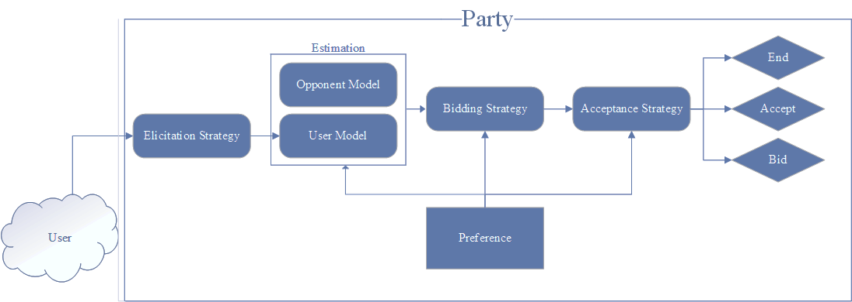
Fig. 10. EUBOA framework components are the Elicitation strategy, User model, Bidding Strategy, Opponent model, and Acceptance strategy. The opponent model and User model components make the estimation entity.
EUBOA framework is comprised an Elicitation strategy that decides when and which bid would be asked from the user to get its rank, and User model which tries to model the user preference, and other three components (BOA) which are like the BOA section (section 4.1). NegoSim has provided DefaultElicitationStrategy class as elicitation strategy (see NegoSim/elicitation_strategies/DefaultElicitationStrategy.py) which chooses a bid randomly to elicit and DefaultUserModel class as user model (see NegoSim/user_models/default_user_model.py). To develop an agent with preference uncertainty, we recommend extending AbstractNegoPartyUncertainCondition class. First of all, you have to override the init method, see Fig. 11:
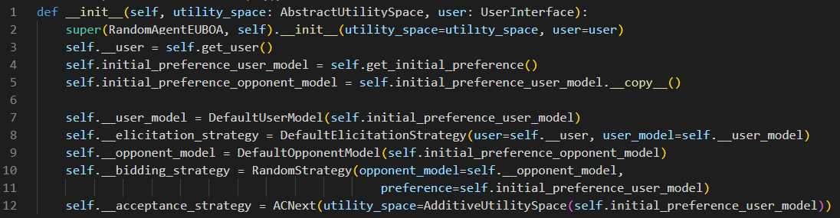
Fig. 11. init method of the agent which works with uncertain preference.
In Fig. 11, in line 3 the user which should be represented by the agent is extracted (self.__user), in lines 4 and 5 the initial preference is assigned to variables self.initial_preference_user_model and self.initial_preference_opponent_model respectively. From lines 7 to 12 the EUBOA components are defined.
To develop the agent with preference uncertainty, the AbstractNegoPartyUncertainCondition's abstract methods need to be implemented. The abstract methods are the same as in table 5.
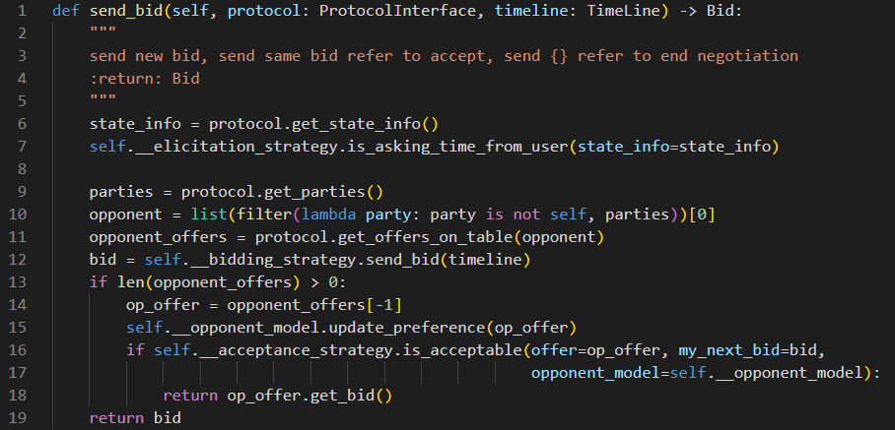
Fig. 12. send_bid method is implemented to decide about accepting the opponent's offer or ending the negotiation or sending a counteroffer.
In Fig. 12, in line 7 the elicitation strategy is called the is_asking_time_from_user method to decide should the user be asked for a certain bid or not. In line 9 all negotiation participants are extracted and consequently, in line 10, the opponent is extracted. The opponent offers are asked from the protocol in line 11. The candidate bid to send to the opponent is generated by the bidding strategy in line 12. In lines 13 to 19, the agent decides whether to accept the opponent's offer or send a counteroffer. You can find a simple agent with preference uncertainty in NegoSim/Agents_uncertainty/RandomAgentEUBOA.py.

Implement Elicitation strategy.
To develop an elicitation strategy we recommend extending AbstractElicitationStrategy class. This class has an abstract method that should be extended (is_asking_time_from_user). An elicitation strategy is obliged to do three tasks:
- Getting initial ranked bids from the user using this line of code initial_ranked_bids = self.ask_initial_ranked_bids_from_user() and submit them to the user model entity to generate initial preference using this line of code user_model.generate_initial_preference(initial_ranked_bids), see lines 2 to 5 in Fig. 13.
- The user model entity might have a question about the order of some bids, so the elicitation strategy has to ask those bids ranking from the user and then updates the user model. See lines 7 to 12 in Fig. 13.
- The elicitation strategy can have an algorithm to ask for the order of bids in order to improve the user model. See lines 14 to 19 in Fig. 13.
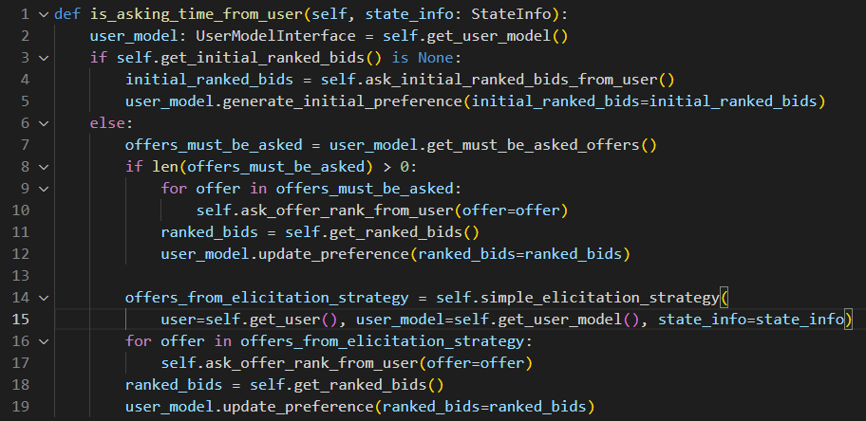
Fig. 13. This figure shows the implementation of the is_asking_time_from_user method.
In Fig. 13, in line 14 the simple_elicitation_strategy refers to the algorithm which is implemented to decide which bid should be asked? See Fig. 14:
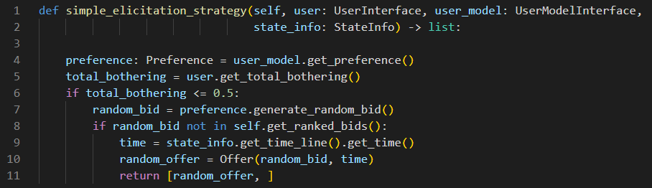
Fig. 14. This figure shows the simple algorithm which is implemented in elicitation strategy. This algorithm simply selects a random bid to ask user.
NegoSim provides a default elicitation strategy which can be found in NegoSim/elicitation_strategies/default_elicitation_strategy.py.

Implement User model.
To develop the user model we recommend extending the AbstractUserModel class. This class has three abstract methods that should be implemented. These three methods are described in table 6.
Table 6. A user model has three abstract methods that should be implemented.
Method | Description
generate_initial_preference | This method generates the initial preferences of the user using initial ranked bids.
get_utility | This method uses the estimated preferences to calculate the utility of a bid.
update_preference | This method updates the user estimated preferences using a sort of ranked bids.

NegoSim provides DefaultUserModel class as a user model (see NegoSim/user_models/default_user_model.py).

- Create an Analysis entity
There are two kinds of analysis entities, one for analyzing negotiation sessions and the other one for analyzing tournament.
  - Analyzing negotiation session
To create an analysis entity, the AbstractAnalysisMan should be extended. This class has two abstract methods which should be implemented. These two methods are described in Table 7.
Table 7. the AbstractAnalysisMan class has two abstract methods that should be implemented.
Method | Description
cal_estimation_analysis_data | This method calculates the performance of the user model and opponent model (if they are existing). This method should return a python dictionary.
get_analysis_data | This method calculates the result of the negotiation session, e.g. utility of each negotiation agent, social welfare, etc. This method should return a python dictionary.

Both of those abstract methods return a dictionary. The dictionary's keys indicate a measurement and the values refer to their values, see Fig. 15.
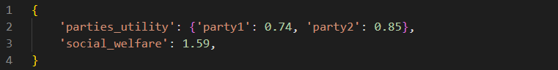
Fig. 15. A python dictionary that the abstract methods of AbstractAnalysisMan class should return.
An AbstractAnalysisMan class has the method save_analysis_data which saves the return data of cal_estimation_analysis_data and get_analysis_data methods as a python pickle (serialized) file. The saved files for a negotiation session can be found in path NegoSim/Gui/logs. If you do not want to save files; you can simply override the save method, see Fig. 16.
Fig. 16. If you do not want the analysis data would be saved, you can override this method.
NegoSim provides three analysis entities in path NegoSim/analysis. These analysis entities are:
- Analysis_man0: this module investigates the utility of agreement for each party and the social welfare value but does not save them as a pickle file.
- AnalysisMan1: this module investigates the utility of agreement for each party and the social welfare value and saves them as a pickle file.
- AnalysisMan2: this module calculates WRMSE [4] for the opponent model and utility of agreement for each party and the social welfare value and saves them as a pickle file.

Unlike other negotiation simulators, NegoSim lets researchers know how their user and opponent modeling works during the negotiation. For example, if you use an opponent modeling algorithm like frequency modeling, for each bid that your algorithm gets, the estimation would be updated. NegoSim provides you to track what happens during the negotiation (on user and opponent modeling). To do that you need to call cal_estimation_analysis_data() method after receiving a bid in the protocol, see section 5.1.

Please Note: NegoSim provides you to track what happens during the negotiation (on user and opponent modeling).

Please Note: if you want to use your developed analysis entity using NegoSim GUI, you have to create a class with the same name as the module name. E.g. if you create a module analysis_man0.py, you should create an analysis_man0 class.

  - Analyzing tournament
A tournament is comprised of several negotiation sessions. The result of each negotiation session (NS) is added to a list and this list can be accessed by calling the get_session_analysis_dataset method. This method (get_session_analysis_dataset) returns a list of dictionaries, e.g. If it is assumed there are two agents ($A_{1}, A_{2}$) and one domain with two preferences $D(p_{1}, p_{2})$ then the tournament has two NSs:
- $NS_{1}$: $A_{1}p_{1} vs. A_{2}p_{2}$ which means agent $A_{1}$ with preference $p_{1}$ negotiates against agent $A_{2}$ with preference $p_{2}$
- ${NS_{2}: A}_{2}p_{1} vs. A_{1}p_{2}$ which means agent $A_{2}$ with preference $p_{1}$ negotiates against agent $A_{1}$ with preference $p_{2}$.
The data would be returned by calling the method get_session_analysis_dataset would be like in Fig. 17.
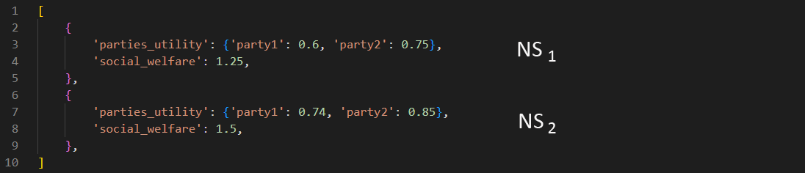
Fig. 17. There are two agents ($A_{1}, A_{2}$) and one domain with two preferences $D(p_{1}, p_{2})$ so the tournament has two NSs: $NS_{1}$, $NS_{1}$.
To create a tournament analyzing entity, the AbstractTournamentAnalysisMan class should be extended. This abstract class has an abstract method (get_tournament_analysis_data) that should be implemented. In this method in order to access the all analysis data of NSs, the method get_session_analysis_dataset should be called and iterate on this list to calculate the average. This method should return a dictionary like Fig. 18.
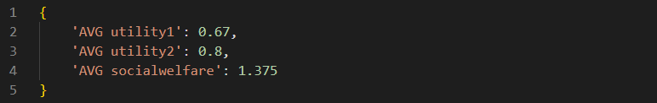
Fig. 18. The python dictionary sample that the get_tournament_analysis_data should return.

As it is mentioned the task of this method is to make an average on data of the session analysis entity, so the tournament and session analysis entity should be compatible with each other, e.g. AnalysisTournament1 (in NegoSim/AnalysisTournament) is compatible with Analysis_man0 and AnalysisMan1. A simple implementation of the get_tournament_analysis_data method is depicted in Fig. 19.

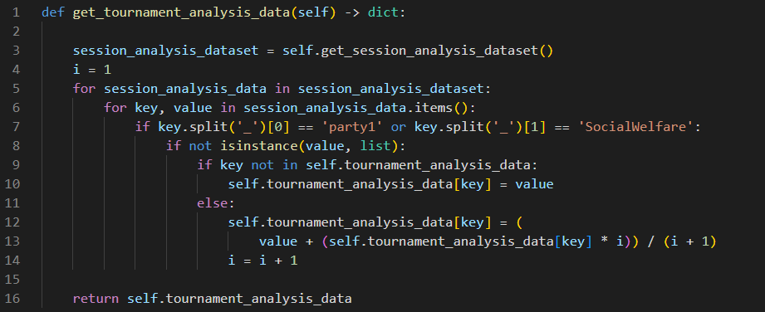
Fig. 19. A simple implementation of the get_tournament_analysis_data method which makes an average on Data which are provided by Analysis_man0 or AnalysisMan1.
In Fig. 18, in line 3 session_analysis_dataset variable is filled with a python list of all negotiation sessions' data of a tournament. In lines 4 to 14, there is an iteration on the session_analysis_dataset variable to make an average. Line 16 returns the analysis data of the tournament. The superclass AbstractTournamentAnalysisMan has the variable self.tournament_analysis_data, which you can use like Fig. 19. Of course, you can simply make a python dictionary variable and return it.

Please Note: get_tournament_analysis_data method should have the ability to make an average python list of Data which are provided by a special session analysis entity, e.g. AnalysisTournament1 is implemented to make on Data that are provided by Analysis_man0 or AnalysisMan1.

Please Note: if you want to use your developed analysis entity using NegoSim GUI, you have to create a class with the same name as the module name. E.g. if you create a module AnalysisTournament1.py, you should create an AnalysisTournament1 class.
- Developing GUI
NegoSim provides some APIs that you can develop your GUI completely modular (NegoSim does not force you to use these APIs to create GUI. For example, the sessionGUI.py module in path NegoSim/GUI was developed without these APIs).
NegoSim APIs for creating GUI use the python Tkinter library. Before explanation of how to create a GUI using these APIs, it would be good to define some elements first that are needed.
- Root frame: the root frame that all other frames and elements would be added to it. The black rectangle in Fig. 20.
- Horizontal frames: the frames that would be added to the root frame. The blue rectangle in Fig. 20.
- Vertical frames: the frames that would be added on a horizontal frame. The green rectangle in Fig. 20.
- Segments: all Tkinter widgets that would be added on a vertical frame are called a segment. The dark red rectangle in Fig. 20.
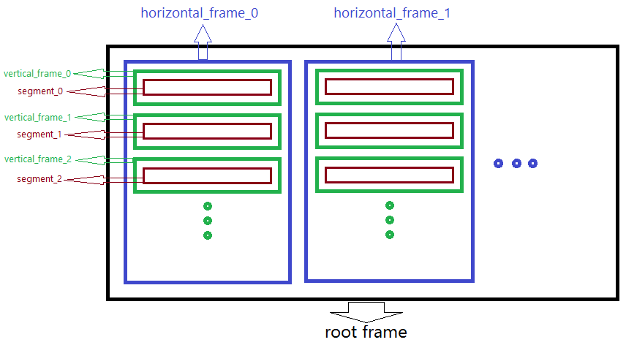
Fig. 20. Black, blue, green, and dark red rectangles refer to the root frame, horizontal frame, vertical frame, and segment respectively.
It would be good to explain a GUI development on an example, so please assume we want to create a GUI like Fig. 21.
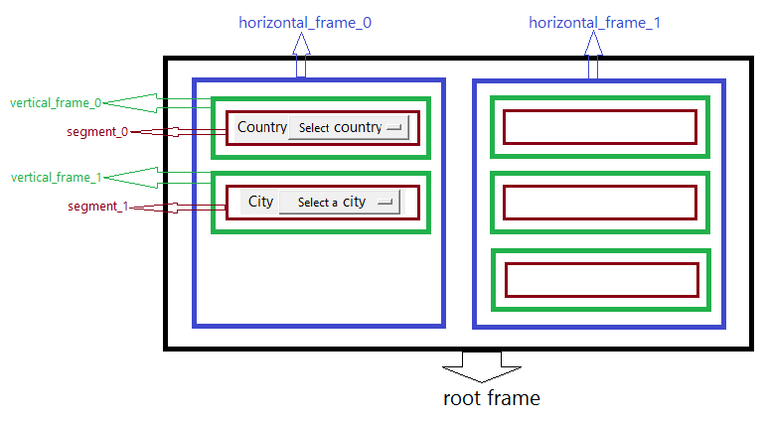
Fig. 21. A sample GUI with 2 horizontal frames. Horizontal frame 0 has two vertical frames. Vertical frame 0 has a segment with 2 Tkinter widgets (a label and an options menu) and so on.
A GUI developer has to create a folder, e.g. my_gui, and then is obliged to do two tasks:
- Develop segments:
  - If it is assumed that we want to create a GUI like Fig. 21, then due to that there are two horizontal frames, so we have to create two folders inside the my_gui folder: horizontal_frame_0 and horizontal_frame_1. (Each folder represents a horizontal frame). The name of these two folders should be in this format: y_x which y refers to a favorite name (we choose horizontal_frame) and x indicates the index of the horizontal frame which is started from 0.
  - For each segment in the horizontal frame, we have to make a segment module, e.g. since the horizontal_frame_0 has two segments, we have to create two modules: segment_0.py, and segment_1.py. The name of these two folders should be in this format: y_x which y refers to a favorite name (we choose "segment") and x indicates the index of the segment which is started from 0.
  - We have to develop each segment, e.g. if we want to develop segment_0.py we have to create a segment_0 class (please note, the name of the module and the class should be the same). segment_0 class should inherit AbstractGUISegment class, see Fig. 22. The abstract class AbstractGUISegment has an abstract method get_widget that should be implemented. This abstract method should return a tuple of Tkinter widgets. As it is shown in Fig. 21, segment_0 has two widgets: a tkinter Label and a Tkinter OptionMenu (a drop-down menu).

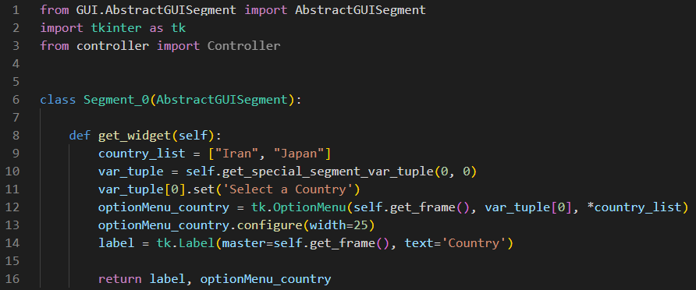
Fig. 22. Segment_0 has two widgets: Label and OptionMenu which are returned by the get_widget method as a tuple.
In line 9 a list of countries is defined which will be shown in OptionMenu (drop-down menu). In the Tkinter library, some widgets like OptionMenu needs a StringVar variable. To reach a StringVar variable you can call get_special_segment_var_tuple(self, horizontal_frame_index: int, segment_index: int) method. This method has two parameters: the horizontal_frame_index parameter which determines the index of a horizontal frame which is 0 in the Fig. 21 example, and the segment_index parameter which determines the index of a segment, which is 0 in the Fig. 21 example. This method returns a tuple of StringVars. The number of this tuple is determined in the configurations.py module which is set to 5 (NUMBER_OF_STRINGVAR = 5), if you need more StringVar for each segment, you can increase this number.

- Create a module in NegoSim/GUI path, e.g. test_gui.py, see Fig. 22:
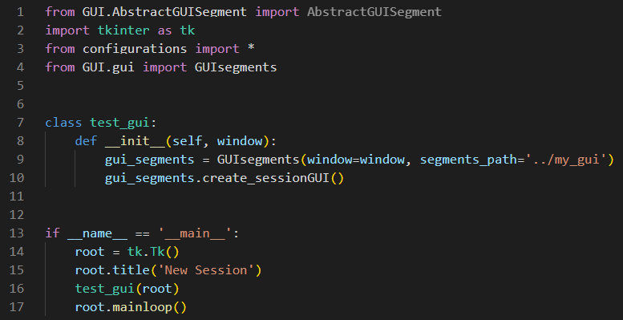
Fig. 23. This module creates a GUI using GUI segments that exist in the '../my_gui' path.
If you run this module a GUI like Fig. 21 would be created. In NegoSim, sessionGUI2.py and tournamentGUI.py GUI modules were developed in this way.

Please Note: every method that you need to develop a GUI, exists in AbstractGUISegment class in path NegoSim/GUI.

- Run NegoSim
There are two ways to run NegoSim (run a negotiation session or tournament):
- Using GUI
- Using NegoSim as a library

  - Run NegoSim using GUI
In order to run NegoSim using GUI, you can simply run module view.py (in path NegoSim/GUI), then you can see a window that shows some information about NegoSim (see Fig. 24).
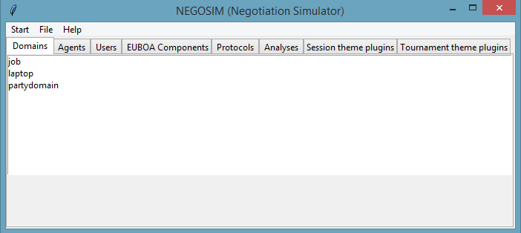
Fig. 24. This is the main window of NegoSim that show some information about NegoSim and its entity.
If you click on start you have two choices: (1) Negotiation, (2) Tournament (see Fig. 25).
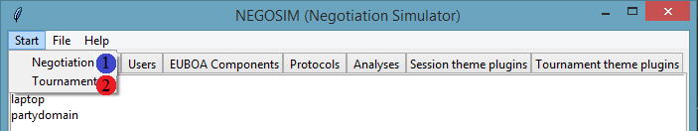
Fig. 25. Start menu of main GUI of NegoSim.

Run a negotiation session:
If you click on Negotiation (Number 1 in Fig. 25), you can run a negotiation session (see Fig. 26).

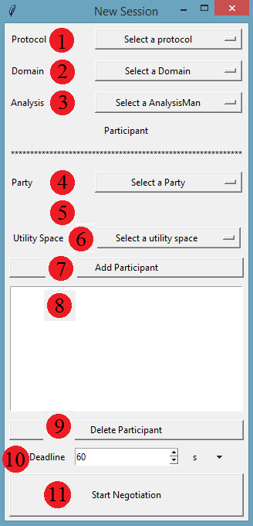  (a) | 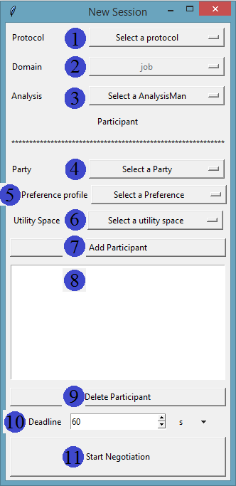  (b)
Fig. 26. The Negotiation session window is shown in (a) and (b). There are 11 widgets. The negotiation settings are determined by them. When a domain is selected (#1 in (b)), the related preference drop-down widget is activated (#5 in (b)).
As it is shown in Fig. 26, the negotiation session window has 11 widgets in which the user can determine the settings of the negotiation session. The widgets of the negotiation session window are explained in table 8:
Table 8. Description of widgets of the negotiation session window.
Widget number | description
#1 | You can choose a protocol for the negotiation session
#2 | You can choose a domain for the negotiation session (e.g. Job domain)
#3 | You have to choose an analysis entity for the negotiation session. This entity will monitor the negotiation session and analyze the negotiation session result and the agent's performance.
#4 | You can select a party for the negotiation session.
#5 | You can choose a preference for the agent using this widget.
#6 | You can select a utility space for the agent. E.g. you can choose 'additive_utility_space' for the agent. NegoSim lets the agents negotiate against each other with different utility spaces.
#7 | You can add first and second negotiation agents to the #8 list box widget using this button. After adding an agent you can change the values of #4, #5, and #6 and add another agent to the #8 list box. These two agents will negotiate against each other.
#8 | This list box widget shows the negotiation agents and their preferences and their utility spaces.
#9 | You can use this button if you want to delete the current agent and select another agent.
#10 | You have to determine a deadline for the negotiation session.
#11 | You can start the negotiation session using this button.

After clicking on the Start Negotiation button (#11), the negotiation will be started. After finishing the negotiation session the result window will be shown as Fig. 27 (black rectangle).
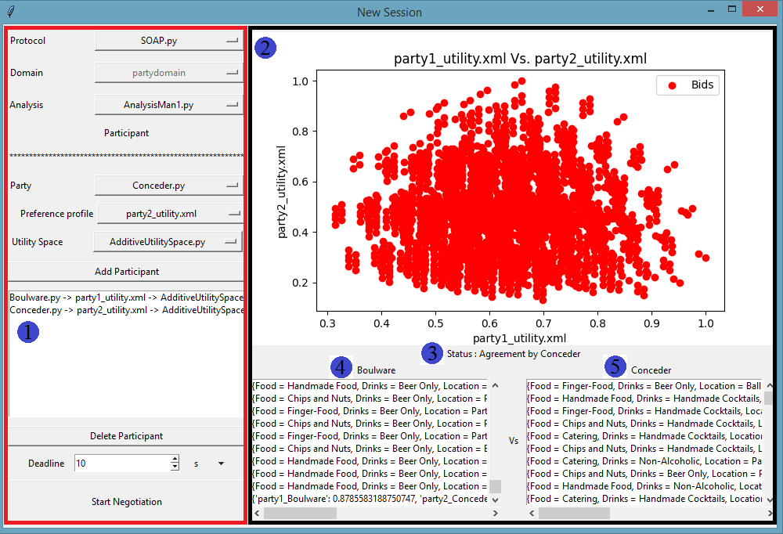
Fig. 27. There are red and black rectangles. The red rectangle shows the settings of the negotiation session and the black rectangle shows the results of the negotiation session.
All exchanged offers, and results of negotiation are shown in the console, but if you want to save all details, you need to make your particular session and tournament analysis entity, see section 7.

In Fig. 27 red rectangle shows the settings of the negotiation session. In this example SOAP, partydomain, and AnalysisMan1 were selected as protocol, domain, and analysis entity, respectively, and the deadline was valued at 10 seconds.
The list box widget (#1) shows two agents: 1) Boulware party with party1_utility.xml as preference and AdditiveUtilitySpace as its utility space. 2) Conceder party with party2_utility.xml as preference and AdditiveUtilitySpace as its utility space.
In Fig. 27 black rectangle shows all possible outcomes as a diagram (#2), the result of the negotiation session (#3) (in this example the result of the negotiation is agreement), Boulware's offers (#4), and Conceder's offers (#5). The last row of the list box widget in #4 and #5 is shown the utility and social welfare.
In this way of running a negotiation session, the analysis data is saved in NegoSim/GUI/logs.

Run a tournament:
If you click on Tournament (Number 2 in Fig. 25), you can run a tournament (see Fig. 28).
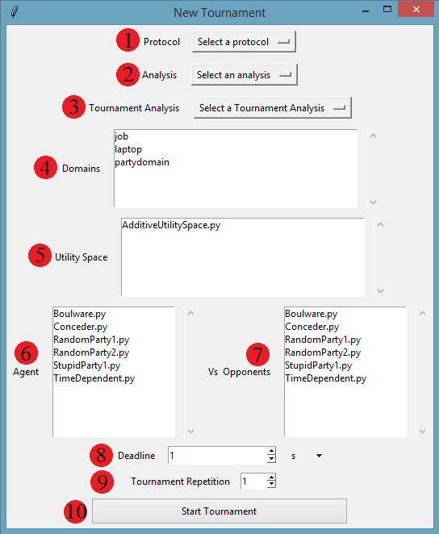
Fig. 28. A tournament GUI window.
As it is shown in Fig. 28, the tournament window has 10 widgets where the user can define a setting for the tournament. Table 9 is detailed all widgets.
Table 9. Description of widgets of Tournament GUI.
Widget number | description
#1 | You can choose a protocol for negotiation sessions of the tournament using this widget, e.g. SOAP protocol.
#2 | You have to select an analysis entity for each negotiation session of the tournament, e.g. Analysis_man0.
#3 | You should choose a tournament analysis entity to analyze the tournament, e.g. AnalysisTournament1.
#4 | You can choose one or more domains for the tournament. NegoSim iterates over all preferences of all domains.
#5 | You can choose one or more utility spaces for agents in a tournament. For example, if you choose two different utility spaces, NegoSim iterates over all selected utility spaces and assigns these utility spaces to agents.
#6 | You have to choose one or more agents using this widget. The agents that the user selected will negotiate against opponents. NegoSim analyzes the results and performance of these agents.
#7 | You have to choose one or more opponents using this widget. The agents that the user selected in #6 will negotiate against opponents.
#8 | You can choose a deadline for the negotiation sessions of the tournament.
#9 | If you want, your tournament to be repeated, you can set this widget to more than one.
#10 | You can start the negotiation using the Start Tournament button.

After clicking on the Start Tournament button, the tournament is started. After finishing the tournament the tournament GUI window will be like Fig. 29.

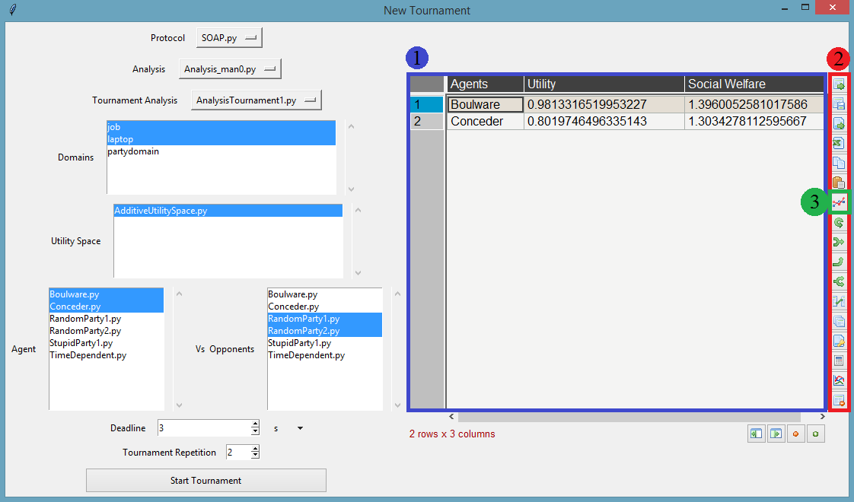
Fig. 29. The results of the tournament are shown as a table.
Fig. 29 shows a tournament in which SOAP, Analysis_man0, and AnalysisTournament1 were selected as protocol, analysis entity for negotiation sessions, and analysis entity for the Tournament, respectively. Job and laptop were selected as domains of the tournament which NegoSim iterated over all preferences of these two domains. The only utility space that is selected for the negotiation parties is AdditiveUtilitySpace, so NegoSim assigns this utility space to all negotiation parties. Boulware and Conceder were selected as the agents who negotiated against RandomParty1 and RandomPary2 as opponents. NegoSim investigates the results and performance of the agents (in this example Boulware and Conceder). The results of Boulware and Conceder are shown in the blue rectangle (#1). NegoSim uses pandastable library [5] to show the results that have been prepared by the tournament analysis entity. On the right side of the result window of the tournament GUI, there is a toolbox (red rectangle #2) that provides some facilities. E.g. the user can make a chart using the tool that is signed with the green square (#3), see Fig. 30.
A tournament is consisting of several negotiation sessions, and the analysis data for each negotiation session is stored in path NegoSim/GUI/logs. The analysis data of a tournament are stored in path NegoSim/GUI/TournamentLogs.
All exchanged offers, results of negotiation, and tournament are shown in the console, but if you want to save all details, you need to make your particular session and tournament analysis entity, see section 7.
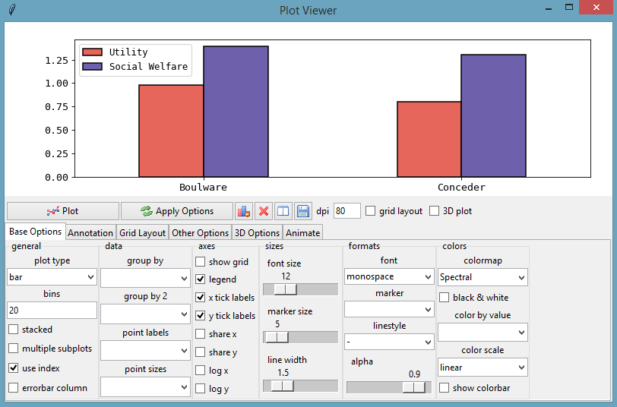
Fig. 30. The results of the tournament are shown as a bar chart.
  - Run NegoSim as a library

Run a negotiation session:
To use NegoSim as a library you can make a folder inside of NegoSim folder and then create a python module (e.g. see NegoSim/Run/run_session.py) and write a piece of code like Fig. 31:

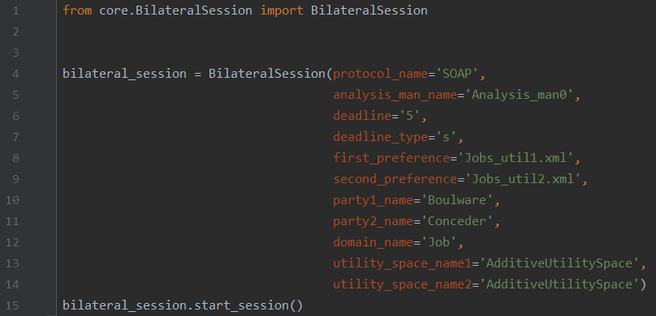
Fig. 31. A module that uses NegoSim as library and run a negotiation session. first_preference and second_preference was defined as a string.
You need to import BilateralSession class from core.BilateralSession (line 1 in Fig. 31). In line 4, an instance of BilateralSession is created. The init method of BilateralSession class has 11 arguments which are detailed in table 10:

Table 10. Arguments of class BilateralSession and their descriptions.
Argument | description
protocol_name | In this argument the protocol name that you want to run the negotiation under its rules should be determined. This variable should be a string, e.g. if we want use the SOAP protocol, then we have to send 'SOAP' as protocol_name. If we send 'SOAP' as protocol_name, it means there is a module with name SOAP.py in path core/protocols, line 4 in Fig. 31.
analysis_man_name | In this argument the analysis entity that you want to analyze the negotiation with it should be determined. You can choose a module from path core.analysis. For example if you want to choose module Analysis_man0.py then you should send string ' Analysis_man0', line 5 in Fig. 31.
deadline | In this argument you have to send a string as deadline of the negotiation, e.g. if you want your negotiation deadline would be 5 second/millisecond then send string '5' (see line 6 in Fig. 31).
deadline_type | This argument could receive strings 's' or 'm' as second or millisecond respectively, line 7 in Fig. 31.
first_preference | First preference of a domain for the first agent. This argument could receive a string or an object:  a) A string: You can choose a preference that there is in path core.Domains, line 8 in Fig. 31.  b) An object: you can create a preference object, see line 4 and line 10 in Fig. 32.  Please Note: both first preference and second preference should belong same domain. In Fig. 31 both first and second preferences belongs Job domain.
second_preference | First preference of a domain for the first agent. This argument could receive a string or an object:  a) A string: You can choose a preference that exists in path core.Domains, line 9 in Fig. 31.  b) An object: you can create a preference object, see line 4 and line 10 in Fig. 32.  Please Note: both first preference and second preference should belong same domain. In Fig. 24 both first and second preferences belongs Job domain.
party1_name | The first agent's name should be sent here. You should choose an agent from path NegoSim/Agents. E.g. if you choose Boulware.py, then you should send it as a string 'Boulware', line 10 in Fig. 31.
party2_name | The second agent's name should be sent here. You should choose an agent from path NegoSim/Agents. E.g. if you choose Boulware.py, then you should send it as a string 'Conceder', line 11 in Fig. 31.
domain_name | In here you have to send a domain name which you have selected your preferences from that. In Fig. 31, since the preferences have been selected from Job domain, you have to send it as a string 'Job', line 12 in Fig. 31. Domain names are defined as folder which contains preferences. There are some predefine domains in path NegoSim/Domains: Job, laptop.
utility_space_name1 | Please Note: NegoSim does not force the developer to use the same utility space for both negotiators, so each agent can have their own utility space.  This argument receives the utility space for the first agent. You can choose the utility space from path NegoSim/utility_spaces. E.g. if you choose AdditiveUtilitySpace.py, you have to send it as a string ' AdditiveUtilitySpace'.
utility_space_name2 | Please Note: NegoSim does not force the developer to use the same utility space for both negotiators, so each agent can have their own utility space.  This argument receives the utility space for the second agent. You can choose the utility space from path NegoSim/utility_spaces. E.g. if you choose AdditiveUtilitySpace.py, you have to send it as a string 'AdditiveUtilitySpace'.

Class BilateralSession makes a choice for the users in order to send a preference; users can send it as a string like line 8 and line 9 in Fig. 31 or send it as an instance of Preference class (line 4 and line 10 in Fig. 32). After creation of an instance of class BilateralSession, you should call start_session method, line 15 in Fig. 31.
Fig. 32 shows another implementation that uses an instance of preferences.
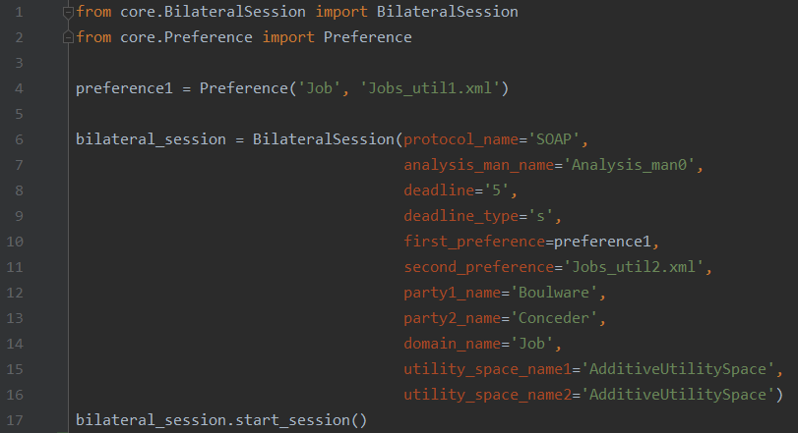
Fig. 32. A module that uses NegoSim as a library and runs a negotiation session. first_preference and second_preference were defined as an instance of class Preference and a string, respectively.
In Fig. 32, line 2, class Preference was imported from core.Preference. In line 4, an instance of class Preference was created (section 4 detailed how you can create an instance of Preference in different ways). In line 10, the created instance of Preference was sent as the first_preference argument. Now, you can run this module.
In this way of run negotiation session, the analysis data are saved at NegoSim/Run/logs.
All exchanged offers, results of negotiation are shown in the console, but if you want to save all details, you need to make your particular session and tournament analysis entity, see section 7.

Run a negotiation tournament
To use NegoSim as a library you can make a folder inside of NegoSim folder and then create a python module (e.g. see NegoSim/Run/ run_tournament.py) and write a piece of code like Fig. 33:
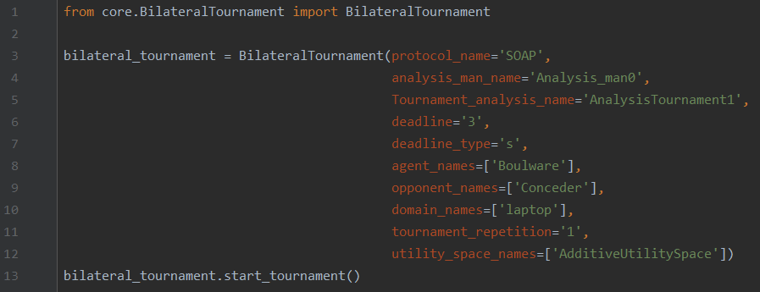
Fig. 33. A module that uses NegoSim as a library and runs a Tournament.
In Fig. 33, line 1 class BilateralTournament was imported from core.BilateralTournament. In line 3, an instance of class BilateralTournament was created. Class BilateralTournament has 10 arguments which are detailed in table 11.
Table 11. Arguments of BilateralTournament and their description.
Method | Description
protocol_name | In this argument the protocol name that you want to run the negotiation under its rules should be determined. This variable should be a string, e.g. if we want use the SOAP protocol, then we have to send 'SOAP' as protocol_name. If we send 'SOAP' as protocol_name, it means there is a module with name SOAP.py in path core/protocols, line 3 in Fig. 33.
analysis_man_name | In this argument the analysis entity that you want analyze the negotiation session with it should be determined. You can choose a module from path core.analysis. For example, if you want to choose module Analysis_man0.py then you should send string ' Analysis_man0', line 4 in Fig. 33.
tournament_analysis_name | This argument receives tournament analysis entity which was defined in path NegoSim\AnalysisTournament. E.g. if you want to select module AnalysisTournament1.py, you have to send it as string ' AnalysisTournament1', line 5 in Fig. 33.
deadline | In this argument you have to send a string as deadline of the negotiation, e.g. if you want your negotiation deadline would be 3 second/millisecond then send string '3' (see line 6 in Fig. 33).
deadline_type | This argument could receive strings 's' or 'm' as second or millisecond respectively, line 7 in Fig. 33.
agent_names | This argument receives a list of agents that should negotiate against opponent agents, line 8 in Fig. 33. NegoSim analyzes the result and performance of these agents.
opponent_names | This argument receives a list of agents as opponents that should negotiate against agents, line 9 in Fig. 33.
domain_names | This argument receives a list of domain names. NegoSim iterates over all preferences of these domains, line 10, Fig. 33.
tournament_repetition | This argument receives a string that determines how many times the tournament should be repeated. E.g. if you want the tournament would be repeated 2 times, you should send it a string '2'. NegoSim averages on the analysis data.
utility_space_names | Please Note: NegoSim does not force the developer to use the same utility space for both negotiators, so each agent can have their own utility space.  This argument receives a list of utility spaces. You can choose the utility space from path NegoSim/utility_spaces. E.g. if you choose AdditiveUtilitySpace.py, you have to send it as a string 'AdditiveUtilitySpace'. The class BilateralTournament iterates over list of utility spaces.

After the creation of an instance of BilateralTournament, you have to call the start_tournament method, line 13 in Fig. 33. Now, you can run this module.
In this way of running a tournament, the analysis data, for sessions are saved at NegoSim/Run/logs and for tournament are saved at NegoSim/Run/TournamentLogs.
All exchanged offers, results of negotiation and tournament are shown in the console, but if you want to save all details, you need to make your particular session and tournament analysis entity, see section 7.

References
- Aydoğan, Reyhan, et al. "Alternating offers protocols for multilateral negotiation." Modern approaches to agent-based complex automated negotiation. Springer, Cham, 2017. 153-167.
- Baarslag, Tim. Exploring the strategy space of negotiating agents: A framework for bidding, learning and accepting in automated negotiation. Springer, 2016.
- Baarslag, Tim, Koen Hindriks, and Catholijn Jonker. "Acceptance conditions in automated negotiation." Complex Automated Negotiations: Theories, Models, and Software Competitions. Springer, Berlin, Heidelberg, 2013. 95-111.
- Tunalı, Okan, Reyhan Aydoğan, and Victor Sanchez-Anguix. "Rethinking frequency opponent modeling in automated negotiation." International Conference on Principles and Practice of Multi-Agent Systems. Springer, Cham, 2017.
- pandastable, https://pandastable.readthedocs.io/en/latest/.

